Assignment #5 – Exploratory Analysis in Python (2)

Consider the churn.csv dataset:

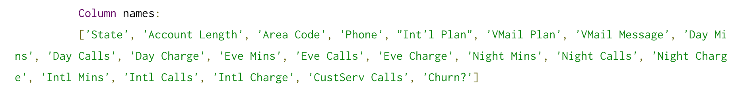

**Step 1**

Estimate the probabilities, the Gini index and the entropy index for the target feature "churn?"

**Step 2**

Compute the Pearson index of "Int Min" and "Int Calls"

**Step 3**

Compute the odds ratio of "churn?" and "Area code"